Referencemateriale:

Websters Instrumentmageroversigt: www.adlerplanetarium.org/history/websters/

Nyere refererencelitteratur: www.etesseract.com/NewReference/NewReference.html
- Bogen Directory of British Scientific Instrument Makers 1550-1851 af kurator Gloria Clifton, National Maritime Museum, Greenwich (London: Zwemmer/NMM, 1995) giver detaljerede oplysninger om mere end 5000 videnskabelige instrumentmagere og instrumentsælgere, der var aktive i Storbrittanien mellem 1500 og 1851.
- Artiklen Historic Scientific Instruments and the Teaching of Science: A guide to resources. Artiklen findes på: www.usyd.edu.au/su/macleay/CSciInstGuide.htm
- Artiklen Davis Quadrants in America af Deborah Jean Warner. Artiklen er i Rittenhouse, vol. 3, # 9, november 1988, pp. 23-40.
Se Rittenhouse Author Index: www.rittenhousejournal.org/txt_auth.pdf

A) Davis-kvadranter til salg aktuelt

Tesseract [New York, USA]
 |  | Salgspris: $5.970 + gebyrer og skat
Nationalitet: | Maker: James Rich | Datering: 1771
Referencer: http://www.adlerplanetarium.org/history/websters/r.htm
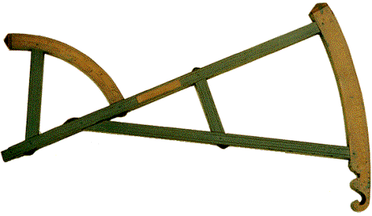 |  | Signed on the inlaid boxwood plaque "JAMES RICH 1771." Measuring 22-11/16" overall, this handsome example of a Davis quadrant is made of rosewood, apparently, with arcs of boxwood, and has fine patina. The wood stock is a full 5/8" thick, the joints mortised then pinned through the tenons. The main arc is hand divided every five arcminutes from 0° to 25° (and back again from 65° to 90°), with transversal scales reading to one arcminute(!).  The short arc is divided every degree from 0° to 65°.The wood is punched with finely shaped 18th century numerals, and is decorated with incised lines throughout. The instrument has a lovely carved "handle," and various punched Tudor rose, fleur-de-lys, and star patterns. The maker, James Rich, is known to Clifton, her entry being based on this very backstaff. A significant example.  DIMENSIONS: 22-11/16" overall.  CONDITION: Very fine, noting a few old stains, and some relatively minor age cracks, one with an old repair.
Links: www.etesseract.com/Navigation/Navigation.html#Handsome

Firmakontakt: Tesseract, Box 151, Hastings-on-Hudson, New York 10706, USA
Phone: 001-914-478-2594, Fax: 001-914-478-5473, Mail: coffeen@aol.com

Hyland Granby [Hyannis Port, USA]
 |  | Salgspris: ? + gebyrer og skat
Nationalitet: Am. eller engelsk | Maker: Seth Halit | Datering: 1794
Referencer: -
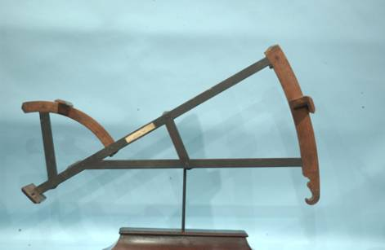 |  | Ebony and boxwood backstaff, signed on an inlaid bone plate: "Seth Halit 1794". The larger arc is graduated 0 to 25 degrees and the smaller arc is divided 0 to 60 degrees. Both arcs are made of boxwood and have typically carved fancy ends. The limbs are made of ebony and are mortised and tenoned and have metal pins. Each side of the limb has a pair of scribe lines. Backstaffs are considered by many as the most beautiful of all navigational instrument and are extremely rare.  DIMENSIONS: Length 25,5 inches; Height 14 inches.  CONDITION: The instrument has a beautiful untouched surface. There is wood loss to the top of the large arc and a few minor nicks to the limbs. The horizon vane is original, and the sighting and shadow vanes are replaced.
Links: http://www.hylandgranby.com/hygr.php?pg=c1

Firmakontakt: Hyland Grandby Antiques, P.O.Box 457, Hyannis Port MA02647 USA
Phone: 001-508-711-3070, Mail:alan@hylandgranby.com

B) Auktionsresultater (’historiske’ data til sammenligning)

1) Sotheby's [London] – 15. juni 2004
Katalog nr. 12 | Vurdering: £ 2.000-2.500 | Salgspris: £ 2.400 + gebyrer og skat
Nationalitet: Engelsk | Maker: Isaac Gorham | Datering: 1763
Referencer: -
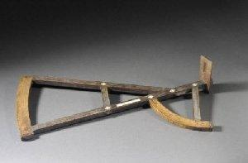 |  | A BOXWOOD AND LIGNUM BACKSTAFF MARKED BY ISAAC GORHAM, ENGLISH, DATED 1763, overall length 56cm (22in.) the lignum frame inset with ivory diamond insets at the joints, with boxwood arcs stamped and decorated with Tudor roses and stars, the sight vane arc is numbered 0 25 and 65-90, the smaller vane for the shadow vane is divided into 60, inset with ivory name plaque stamped and dated Isaac Gorham 1763 complete with single sighting vane.
Links:

Firmakontakt: www.sothebys.com
Catherine Southon (Head of Department), Scientific Instruments, Phone: 0044 20 7293 5209, Fax: 0044 20 7293 5915
catherine.southon@sothebys.com

2) Sotheby's [Olympia] – 16. december 2003
Katalog nr. 28 | Vurdering: £ 3.000-4.000 | Salgspris: ikke solgt
Nationalitet: Engelsk | Maker: - | Datering: 1763
Referencer: -
A BOXWOOD AND LIGNUM BACKSTAFF, ENGLISH, DATED 1763.
(måske ovennævnte objekt?)
Links:

Firmakontakt: www.sothebys.com
Catherine Southon (Head of Department), Scientific Instruments, Phone: 0044 20 7293 5209, Fax: 0044 20 7293 5915
catherine.southon@sothebys.com

3) eBay Internet Auctions [USA] – 7. februar 2003
Katalog nr. 2505039773 | Vurdering: - | Salgspris: $ 5.750 + shipping og told
Nationalitet: Amerikansk | Maker: Benjamin King | Datering: ca. 1760
Referencer: http://www.adlerplanetarium.org/history/websters/k.htm
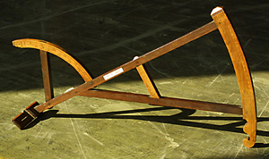 |  | AMERICAN, 1760?, signed "Made by Benjamin King in Newport Rhode Island", and on the rosewood main frame on an ivory plate "Captn E Burt", rosewood limbs, boxwood arcs, boxwood brace, near objective vein 60 degree, 30 degree signature brace, 22 1/2" radius, 25 degree divided by 1 degree, subdivided to 10 min., original horizon vein, probable declination and right ascension scale engraved on the opposing side of the 30 degree main arc, an early American Davis quadrant or backstaff.
Links: http://www.uzes.net/marketwatch/tcsmw/catchup03/kingquadrant.htm

Firmakontakt: http://stores.ebay.com/Science-Instruments-Odd-and-Curious

4) John D. Julia Auctioneers – 22. august 2002
Katalog nr. 127 | Vurdering: $ 3.000-5.000 | Salgspris: $1.840 + gebyrer og skat
Nationalitet: - | Maker: ? | Datering: -
Referencer: -
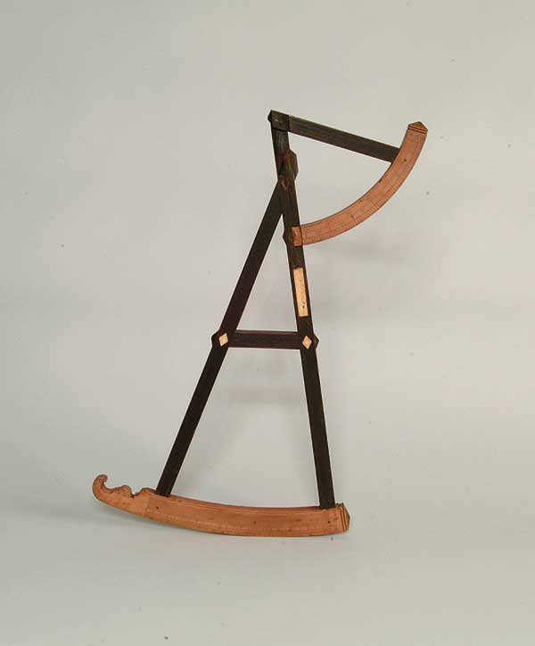 |  | EARLY DAVIS STYLE BACKSTAFF "MADE FOR MR. JOSEPH LIGHT". Backstaff is made of various woods including mahogany and holly. Inset ivory plaque and diamonds. Carved scales. SIZE: 20.25in CONDITION: Missing slide to each scale, point at which top scale meets staff has broken and parts missing, in need of repair
Links:

Firmakontakt:

5) Skinner Inc. [Bolton, USA] – 3. juni 1999
Katalog nr. 28 | Vurdering: $ 6.000-8.000 | Salgspris: $ 6.325 + gebyrer og skat
Nationalitet: Amerikansk | Maker: Benjamin King | Datering: 1768
Referencer: http://www.adlerplanetarium.org/history/websters/k.htm
American Davis-Pattern Backstaff, signed "Made By Benjamin King in Newport Rho Island 1768," with rosewood main limbs, boxwood greater arc divided 0- 25 by 1s and 65-90' by Ss between a diagonal scale, the reverse with latitude and departure chart , both sides with punched star decoration, the lesser arc divided 0- 60 by 10s and 0-65 by Ss (65 extending onto the main limb), the cross-member with signature and the main limb with section for owner's label, lg. 24. 5in. Literature: Davis Quandrants In America, by Deborah Jean Warner, Rittenhouse, vol. 3, issue 9, November 1988, pp. 23-40 Warner records fourteen other backstaffs by King, but does not include this one. The chart was a feature unique to King.
Links:

Firmakontakt: Nick Hawkins, Department Head, Science & Technology
Skinner, Inc., 357 Main Street, Bolton, MA 01740, Phone: 001 978-779-6241, Fax: 001 978-779-5144

6) Sotheby's [London] – 26. februar 1998
Katalog nr. 439 | Vurdering: £ 2.000-3.000 | Salgspris: ? + gebyrer og skat
Nationalitet: Engelsk | Maker: - | Datering: ca. 1750
Referencer: -
A Rosewood and boxwood backstaff English, mid 18th century with rosewood frame and boxwood arcs, the 30o arc is divided to 5 minutes from 0-60, the larger shadow arc divided from 0-25-65-90 64cm (25,25inch) long.
Links: Gengivet I farve I auktionskataloget p. 130

Firmakontakt: www.sothebys.com
Catherine Southon (Head of Department), Scientific Instruments, Phone: 0044 20 7293 5209, Fax: 0044 20 7293 5915
catherine.southon@sothebys.com

7) Philips [London] – 16. december 1997
Katalog nr. 18 | Vurdering: £ 800-1.200 | Salgspris: ? + gebyrer og skat
Nationalitet: Engelsk | Maker: John Dobson | Datering: 1741
Referencer: -
A 25.5inch Lignum Vitae and Boxwood Backstaff, bearing an inlaid plaque stamped. Made By Iohn Dobson For Iohn Percevell 1741. The frame decorated by scribed parallel lines, the main scale on the smaller arc graduated to 65 degrees with secondary scale graduated in 5 degree intervals with allowance for the suns semi-diameter. The large arc damaged graduated to 25 degrees and reading to 1 minute of arc by means of a diagonal scale, both arcs decorated by rose and star stamps, vanes lacking
Links:

Firmakontakt: www.sothebys.com
Catherine Southon (Head of Department), Scientific Instruments, Phone: 0044 20 7293 5209, Fax: 0044 20 7293 5915
catherine.southon@sothebys.com

8) Sotheby's [New York] – 22. februar 1996
Katalog nr. 475 | Vurdering: $ 3.500-4.500 | Salgspris: ? + gebyrer og skat
Nationalitet: Amerikansk | Maker: Clark Elliott | Datering: 1762
Referencer: www.adlerplanetarium.org/history/websters/e.htm
A Rare American Davis Quadrant Backstaff, C. Elliott, New London, no. 297, 1762, redwood and boxwood, smaller scale engraved from 0 to 65 degrees, the large scale 0 to 25 degrees and 65 to 90 degrees, with two sighting vanes, one with lens and a third replaced, signed on cross piece, made by C. Elliott, New London, for Mr James Smith 1762, the instrument and two vanes numbered 297 Length 61.7 cm. While the horizon vane and the shade vane are both original, the sight vane is a reproduction of an original at the Peabody Museum, Harvard. A Paris quadrant by C. Elliott for Asa Waterman, 1765, was a loan to Mystic Seaport Marine Historical Association, Mystic, Conn., with a letter from the assistant curator dated Sept. 2, 1959 Another, made by C. Elliott for Mr. Prentice Peabody, New London, 1768, no. 367, is in a private collection. Clark Elliott 1732-1793 served his apprenticeship with Thomas Greenough and set up business in New London. his account books, which survive at the New London Historical Society, list 403 quadrants, both Davis and the newer Hadley type, but few are known today. See, "Davis Quadrants in America" by Deborah Jean Warner, an article published in Rittenhouse, Vol. 3, No. 1, 1988 where the present instrument is listed.
Links:

Firmakontakt: www.sothebys.com
Catherine Southon (Head of Department), Scientific Instruments, Phone: 0044 20 7293 5209, Fax: 0044 20 7293 5915
catherine.southon@sothebys.com

9) Philips [London] – 14. marts 1995
Katalog nr. 34 | Vurdering: £ 1.200-1.800 | Salgspris: ? + gebyrer og skat
Nationalitet: Engelsk | Maker: - | Datering: 1763
Referencer: -
An 18th Century lignum vitae and boxwood Backstaff, the main scale ranging from 0-25/60-90, the mirror are scale from 0-60, with fleur de lys and rosette punched decoration and a silver nameplate signed Ino. Monkhouse, 64cm. 2ft. 1in. Wide.
Links:

Firmakontakt: www.sothebys.com
Catherine Southon (Head of Department), Scientific Instruments, Phone: 0044 20 7293 5209, Fax: 0044 20 7293 5915
catherine.southon@sothebys.com

10) Christies [South kensington Ltd.] – 2. November 1995
Katalog nr. 113 | Vurdering: £ 1.800-2.200 | Salgspris: ? + gebyrer og skat
Nationalitet: Engelsk | Maker: John Lloyd | Datering: 1740
Referencer: www.adlerplanetarium.org/history/websters/l.htm
A mid 19th Century 'Davis' backstaff, the frame of lignum vitae with boxwood scales and makers plaque emgraved John Lloyd 1740 with fleur-de -lys decoration, the smaller arc divided 0-65 , 5-60 , 0- 60 , the greater arc divided 65-90 and 0-25 , (scroll end missing)- 64cm radius
Links:

Firmakontakt: Tom Newth (tnewth@christies.com) & Joyce Shaw (joyceshaw@christies.com)
Phone: 0044 (0) 20 7321 3147, Fax: 0044 (0) 20 7321 3321

11) Sotheby’s [London] – 7. oktober 1994
Katalog nr. 23 | Vurdering: £ 2.500-4.000 | Salgspris: ? + gebyrer og skat
Nationalitet: Engelsk | Maker: - | Datering: 1744
Referencer: -
A Rosewood And Boxwood Backstaff, English, dated 1744, the rosewood limbs with boxwood fore and back sights, boxwood owner's plaque engraved Mr Willm Henderson 1744, 64cm(25in long)
Links:

Firmakontakt: www.sothebys.com
Catherine Southon (Head of Department), Scientific Instruments, Phone: 0044 20 7293 5209, Fax: 0044 20 7293 5915
catherine.southon@sothebys.com

12) Korvels [London] - 1995
 | Vurdering: - | Salgspris: $ 8.250
Nationalitet: Amerikansk | Maker: Clark Elliott | Datering: -
Referencer: www.adlerplanetarium.org/history/websters/e.htm
Navigational Backstaff, C. Elliott, Walnut, Cherry
Links:

Firmakontakt: http://kovels.com/Auctions.html

Links:
www.invaluable.com

