På San Rafael Auction Gallery var der i februar 2005 en auktion, hvor der både var en original og 2 kopier til salg (se http://www.sanrafael-auction.com/catalog.htm):

Lot 234: BACKSTAFF QUADRANT. A fruitwood and boxwood Davis's quadrant or backstaff, the solid boxwood shadow vane divided 0-60 to two faces, the sight vane boxwood arc divided 0-25 reading to 5' by diagonal scale and stamped with star decoration. 22", English, second quarter of the 18th century. Fully restored by Ray Powers. Now complete with sighting and shadow vanes and horizontal slit made by Ray Powers. Mounted in plexiglas case. 28" x 16 1/2" x 9". Purchased Sotheby's, London 9/20/1983, Lot 103. Original catalog and copy of bill of sale accompanies this lot, along with vane and slit drawings and a 1984 letter from Saul Moskowitz, Historial Technology, Inc.: Marblehead, MA. ($ 4000-6000)

Lot 236: BACKSTAFF. Reproduction rosewood and boxwood Davis quadrant with ivory detail and ivory plaque "made by Ray Powers, Daly City, Ca. 1984". 22" tall. Accurate and complete. ($ 600-800)

Lot 238: BACKSTAFF. Reproduction mahogany and boxwood. Davis quadrant with ivory inlay. Accurate and complete. Made by Ray powers, Daly City, Ca.1984. 22" long. ($ 450-600)

Lot 51 : A mid-18th century Lignum Vitae and boxwood Davis backstaff
the large arc divided 0-25 and on the higher latice scale between 65- 90, the smaller arc 0-60, the frame with stamped decoration, together with sights and vanes.
24 in. (61 cm.) long
Realiseret pris: formodentlig $ 2.400,-
Christie's, New York, 2005

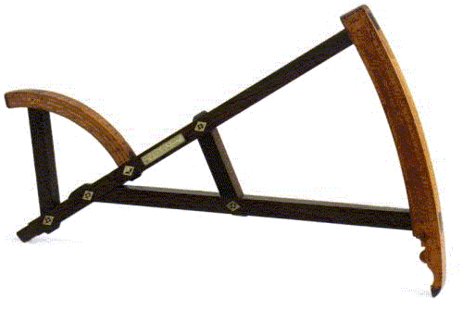
Lot 803 : JAMES HAM, A BACK-STAFF, AMERICAN, DATED 1759
signed on ivory plaques set into the fruitwood frame Made by James Ham In Philad:a with name of owner below scratched reading F[or] ** Henry Soyers[?] 1759, the fruitwood frame with two boxwood arcs. The larger arc stamped with makers initials and No.151, incised with scale reading 0-25º flanked by fleur-de-lys patterns. the smaller arc is incised with a scale divided 0-60º reading to 1º, and 0-60 on the outer edge. A set of diagonals enables readings to be taken to 10 minutes .The overall fruitwood frame inset with simple ivory diamond-shaped forms engraved with geometric patterns, together with three later vanes. length 23in (58.5cm)
Provenance: Time Museum Inventory No. 1469
Litteratur: Bedini, Silvio. Early American Scientific Instruments and their Makers. Washington, 1964, pp. 65-66
Vurdering: $ 5.000-7000,-
Realiseret pris: $ 11.400,-
Sotheby's, New York, 2004

Lot 197 : EARLY DAVIS STYLE BACKSTAFF "MADE FOR MR. JOSEPH LIGHT".
Backstaff is made of various woods including mahogany and holly. Inset ivory plaque and diamonds. Carved scales. SIZE: 20 1/4" CONDITION: Missing slide to each scale, point at which top scale meets staff has broken and parts …..
James D. Julia, Maine, New England, 2002

Lot 288 : A Rosewood and boxwood backstaff
English, mid 18th century with rosewood frame and boxwood arcs, the 30o arc is divided to 5 minutes from 0-60, the larger shadow arc divided from 0-25-65-90 64cm., 25Din. long.
Sotheby's, New York, 1989

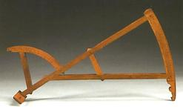
Lot 176: EXTREMELY RARE AND IMPORTANT BACKSTAFF Made entirely of various woods including holly wood and mahogany with an inlaid label which reads "Made By William Hart in Portsmouth N.E./for... 1767". A truly outstanding Eighteenth Century navigational instrument made for distribution by a New England ship chandlery. CONDITION: outstanding, complete.
Bourne, Massachusetts, New England, 1989

Lot 149 : RARE SEVENTEENTH CENTURY EBONY AND HOLLY WOOD BACKSTAFF CONDITION: very well preserved, minus its smaller parts.
Bourne, Massachusetts, New England, 1988.

Auktionsopslag vedr. gamle auktioner på:
http://search.sothebys.com/search/quickSearch/k2/Search.jsp?coll=liveClosed

