Den kunstige horisonts historie

Så længe man har været interesseret i og haft brug for at måle himmellegemers højde over horisonten har man også været opmærksom på det problem, der opstår, når man ikke kan se horisonten.

Problemet er der, hvad enten man færdes til lands eller til vands. Begge steder har man haft brug for at bestemme sin geografiske bredde enten ved måling af plarstjernens højde eller ved måling af solens højde ved middag. På land kan terrænet forhindre, at man kan bestemme en horisont med rimelighed, og både på sø og land kan vejret naturligvis være en forhindring.
I lang tid blev der tumlet med forskellige forslag til bestemmelse af horisonten uden at man kan se den; det er jo et spørgsmål om at bestemme hvad der er en vandret sigtelinje. Historien om disse forslag er bl.a. kort fortalt i Cotter 1983. Libeller med rimelig præcison blev man først i stand til at fabrikere langt oppe i 1700-tallet, men før midten af 1700-tallet opfandt man en brugbar kunstig horisont.

Ifølge Cotter 1983 (p.194) ser det ud til at denne kunstige horisont med kviksølv er opfundet omkring 1740 af George Adams(død 1773), der var instrumentmager i London.
Denne instrumentmager søn, George Adams jun. (1750-1795) beskrev sine instrumenter i et bogværk med titlen Geometrical and Graphical Essays, der udkom 1791. Heri var den kunstige horisont ikke beskrevet. Men anden udgaven af bogen, der udkom i 1797, to år efter George Adams’ død, ”corrected and enlarged by William Jones” indeholder en kort beskrivelse og en afbilding:

THE ARTIFICIAL HORIZON

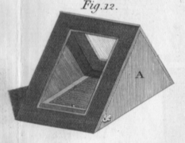
In many cases it happens that altitudes are to be taken on land by the sextant: which for want of a natural horizon, can only be obtained by an artificial one. There have been a variety of these sort of instruments made, but the kind now to be described is allowed to be the only one that can be depended upon. Fig.12, plate 19, represent the horizon fixed up for use. A is a wood or metal framed roof containing two true parallel glasses of about 5 by 3½ inches, fixed not too tight in the frames of the roof. This serves to shelter from the air a wooden trough filled with quicksilver. In making an observation by it with the sextant, the reflected image of the sun, moon, or other object, is brought to coincide with the same object reflected from the glasses of the sextant; half the angle shewn upon the limb is the altitude above the horizon or level required. It is necessary in a set of observations that the roof be always placed the same way. When done with, the roof folds up flatways, and, with the quicksilver in a bottle, &c. is packed into a portable flat case.
[George Adams, 1797, p.285-86]

I anden halvdel af 1800-tallet finder vi følgende beskrivelse af samme apparat i Heathers Mathema-tical Instruments, der udkom i adskillige udgaver; vi citerer her fra den 10. udvidede og reviderede udgave fra 1872:

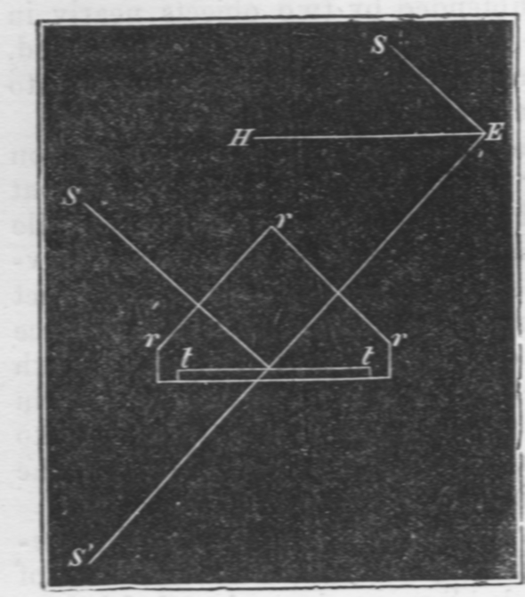
At sea the altitude of an object may be determined by observing the angle subtended by it and the verge of the horizon; but upon land a contrivance, called an artificial horizon, becomes necessary, for correctly determining altitudes. The best kind of artificial horizon consists of an oblong trough, t t, filled with mercury, and protected from the wind by a roof, r r, having in either slope a plate of glass with its two surfaces ground into perfectly parallel planes. The angle, S E S´, between the object and its reflected image seen in the mercury, is double the angle of elevation S E H; and, the angle S E S´ being observed, its half will, consequently, be the angle of elevation required. If the angle of elevation be greater than 60°, the angle S E S´ will be greater than 120°, and cannot be observed with the sextant that we have been describing.
[Heather 1872, vol III, p.52]

Det tungtflydende kviksølv er velegnet til formålet, som det er nævnt i begge disse beskrivelser, men man kan også bruge vand, som er noget mindre sundhedsfarligt.
Et eksempel på en moderne udgave af en kunstig horisont, lavet af plastic, men fuldt funktionel, er Davis Artificial Horizon (se instrumentbeskrivelse).

Kilder og links:

George Adams: Geometrical and Graphical Essays, containing, a General Description of the Mathematical Instruments used in Geometry, Civil, and Military Surveying, Levelling, and Perspective; with many Practical Problems. Illustrated by thirty-four copper plates. The second edition, corrected and enlarged by William Jones. London 1797. (p.285-86 + plate 19).

J.F. Heather: Mathematical Instruments, their Construction, Adjustment, Testing, and Use, comprising Drawing, Measuring, Optical, Surveying and Astronomical Instruments. Enlarged Edition, for the most part entirely re-written. With numerous Illustrations. London 1872. Vol.I-III. (p.52).

Charles H. Cotter: A History of the Navigator’s Sextant, Glasgow 1983. (p.188-206).

Kunstig horisont på Steno Museet (med billede):
http://db.stenomus.au.dk/phptest/showitem.php?current=0&indeks=0&globalsearch=kunstig+horisont&t=1

Netstedet The History of the Sextant: http://www.mat.uc.pt/~helios/Mestre/Novemb00/H61if_2.htm

Netstedet The Mapmakers, An essay in four parts (the exploration of Canada)
http://www.nlc-bnc.ca/2/24/h24-230.2-e.html
med denne illustration:

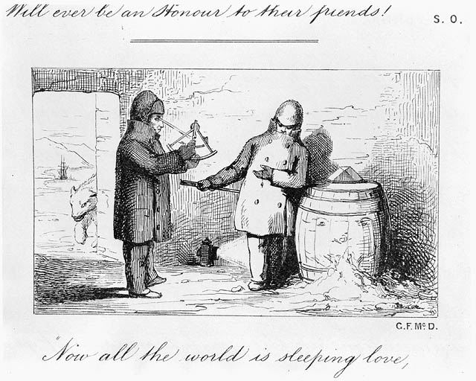

Observing through a sextant
© Public Domain
Credit: National Archives of Canada / C-028283
Source: National Archives of Canada
(http://data2.archives.ca/ap/c/c028283.jpg )

