Engelsk leksikon-artikel om jakobsstaven fra 1765

The Complete Dictionary of Arts and Sciences, in which the Whole Circle of Human Learning is Explained, and the Difficulties attending the Acquisition of Every Art, Whether Liberal or Mechanical, are Removed, in the Most Easy and Familiar Manner.
London, 1765.
Vol. II, art. Fore-Staff.

FORE-STAFF, or CROSS-STAFF, a mathematical instrument used to take the sun’s altitude.

This instrument consists of a staff and four crosses, viz. the tenth cross, the thirtieth cross, the sixtieth cross, and the ninetieth cross.
The staff is a square piece of wood on which the crosses slide, each side being graduated into divisions: the first side has from about three degrees to ten delineated on it; the second from ten to thirty; the third from twenty to sixty; and the fourth from thirty to ninety.
The tenth cross, so called from its belonging to that side of the staff, which is numbered from three to ten degrees, is the shortest of the four crosses, and is to be used when the sun’s altitude is under ten degrees. Sometimes the breadth of the thirtieth cross supplies its place.
The thirtieth cross is longer than that of ten, and belongs to that side of the cross which is numbered from ten to thirty, whence it has its name: when the sun’s altitude is between ten and thirty degrees, this cross is to be used.
The third, or sixtieth cross, so termed from belonging to that side of the staff, which is numbered from twenty to sixty, is longer than the former, and is to be used when the sun’s altitude is between thirty and sixty degrees.
The fourth cross is called the ninetieth cross, because it belongs to that side of the staff which is numbered from thirty to ninety degrees. This cross is used when the sun’s altitude is between sixty and ninety degrees.
The several divisions on the staff are constructed after the following manner.
Let AB (plate LXIV. fig. 7.) represent the side of the staff to be divided; with any convenient radius, setting one foot of the compasses in A, with the other describe the semicircle DEC, and draw the diameter DAC, at right angles to AB: divide each quadrant into ninety equal parts or degrees; at the distance of half the length of the cross, draw the lines Ff, Gg, parallel to AB, and from the center of the circle draw right lines through the several divisions of the quadrants; and, from the intersections of those right lines with the two parallel lines Ff, Gg, draw right lines intersecting the staff AB, which will give the several divisions: thus the line FG, intersecting the staff AB, in the point a, will give the division of twenty degrees, because the angle FAG = twenty degrees: and after the same manner, and by making use of the length of the several crosses, may the four sides of the staff be divided.

To take the sun’s altitude with the FORE-STAFF. - Having adapted the proper cross to the staff, apply the flat end of the staff at A, (fig. 8.) to the outside of the eye, the face being turned towards the sun; look for the object at the upper end of the cross at C, and at the lower end B for the horizon; but, if the sky appear instead of the horizon, slide the cross nearer to the
eye; if the sea appear, remove it farther from the eye, till the object appear at the end C, and, at the same time, the horizon at the end B; then will the cross cut, on the side of the staff proper to it, the degree and minute of altitude. But if the meridian altitude be required, the observation must be continued, and as the object approaches the meridian, the sky will appear at the end B, instead of the horizon; but, when the object begins to descend, the sea will appear at the end B, and then is the observation finshed, and the cross will cut the degrees, &c. of altitude.
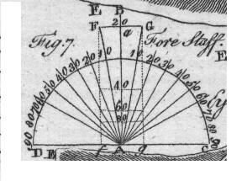
Plate LXIV, fig. 7.
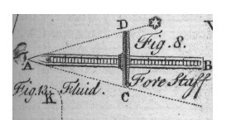
Plate LXIV, fig. 8.

